Tableau Server
The data dashboards are located on Tableau Server: https://tableau.strivetogether.org/#/site/SeedingSuccess/home

Logging In and Changing Your Password
You’ll receive your login information upon successful completion of the Data Use & Literacy training; your username will be your last name and first initial.

Once you login for the first time, you can change your password. In the upper right corner of the page, click on the circle containing your initials. From the dropdown menu, select ‘My Account Settings’. On this page you will find a link called ‘Change Password’. If you are locked out of your account, please email ellen@seeding-success.org.

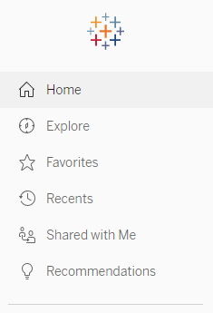
Navigating Tableau Server
Use the menu on the left side of the page to navigate to your data. Click ‘Explore’ to see the folders that you have access to.

Most dashboards (also called Workbooks) can be found in the folder called ‘Lead Authorized Data Users’. The most recent dashboards for partners is called ‘Partner Dashboards - All Years’.

You can also ‘Favorite’ a folder or workbook to easily access it on the Tableau Server front page or menu. To make a Favorite, click the star to the right of the name of the folder or workbook.

Using the Dashboards
Dashboards will often have filters to narrow down the focus of the table or visualization. Look for specific directions for using filters at the top of each dashboard page. Types of filters include partner roster year, school year, and partner classroom. If you’ve applied filters and would like to remove all of them to go back to the original dashboard view, click the ‘Revert’ button in the top menu.
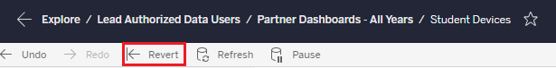

Have questions?
If you have any issues or questions regarding using Tableau Server or data dashboards, email alicia@seeding-success.org.

How-To Download Data from Tableau Server
You can download your data, including tables, charts or whole dashboard pages, to a variety of formats. Open the sheet you would like to work with, and then click “Download”, found at the top of the page. Follow the instructions below for the type of file you would like.

Dashboard pages as images
To download the entire dashboard page as an image “screenshot”, select Image. This will save the screenshot as a .png to your desktop.

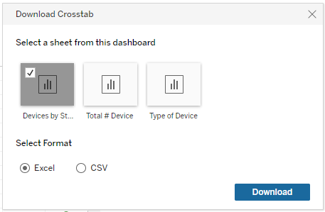
Excel or .CSV files
To download a table into a file you can open in Excel, select Crosstab. Select the name of the table on the page you want to download; you can only select one at a time to download.

Specific charts or graphs as images for a document or powerpoint
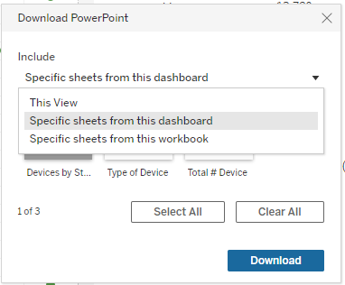
To download parts of the page as images to put into a document or powerpoint, the easiest way to get the images is to select Powerpoint. Then, use the dropdown box as shown to the right:

Then, select all parts of the dashboard page you would like as an image. You can select more than one part (table, chart, etc), and each part selected will be saved as an image on a separate powerpoint slide. You can then use the image in your Powerpoint presentation, or copy and paste it into a Word or Google document.

PDFs
You can also download the entire page, or specific parts, as a PDF by selecting PDF.

