SIPOC

Purpose
A SIPOC (Supplier, Input, Process, Output, Customer) analysis is a high-level view of a process.
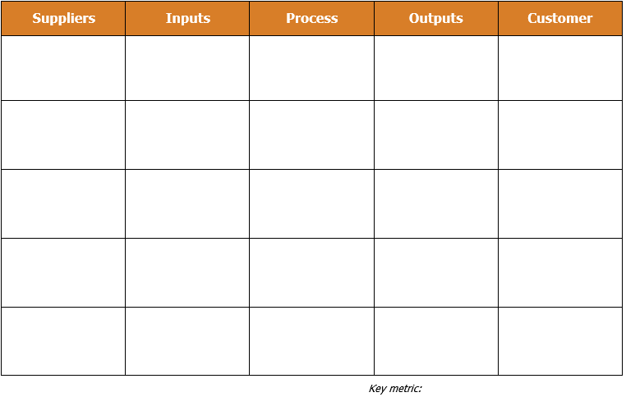
Ordered from start to finish, a SIPOC identifies suppliers who provide inputs to a process, which results in an output that is delivered to customers. This tool helps identify all internal and external factors, and aligns the team with the inputs and outputs that impact the process.

6

4

2

3

5

How to Facilitate
It is essential to complete the SIPOC as a team to validate and increase ownership in the success of the process. Use sticky notes so items can be easily moved around. Each row represents a step in the process, along with the supplier, input, output and customer of that step. Guide your team through the SIPOC in the following order:

1
- Key metric
  - Start by identifying the key metric of the process (i.e. how do you measure the output of the process?). Write the key metric at the bottom of the output column.
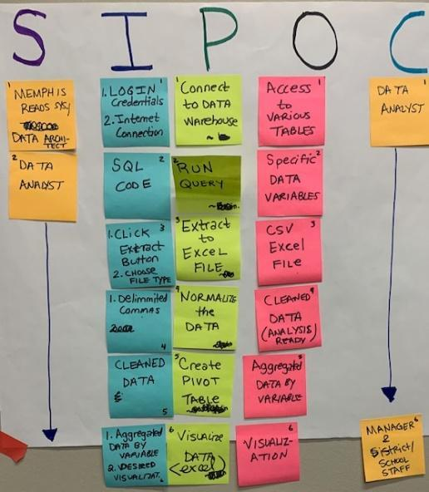
- Process
Fill in the Process column using verbs:
- First, determine the first step of the process;
- Next, determine the last step of the process that produces the key metric;
- Fill in the rest of the process column in order of steps in the process;
- Keep the process high-level by aiming for 5-7 process steps, and validate the scope and boundary of the process with the team.
- Inputs
- Determine the inputs for each process step and fill in the Inputs column. There may be multiple inputs, and inputs may be outputs from the previous process step.
- Outputs
- Determine the outputs for each process step and fill in the Outputs column.

- Suppliers
- Determine the suppliers from whom the inputs come and fill in the Suppliers column. Suppliers could be a person or a system.
- Customers
- Determine the customers of the outputs and fill in the Customers column. Customers may be the person/department/area involved in the next step of the process, and there may be multiple customers.

Suppliers | Inputs | Process | Outputs | Customer
Key metric:

EXAMPLE SIPOC – Baking a Custom Cake

Suppliers | Inputs | Process | Outputs | Customer
Customer | Customer order | Discuss customer cake order | Customer requirements | Baker
Bookstore | Recipe book | Find a recipe | Recipe | Baker
Baker | Recipe, pen, paper | Make a list of ingredients | List of ingredients | Baker’s assistant
Grocery store | List of ingredients, money | Buy ingredients  from store | Ingredients | Baker’s assistant
Radio | Station frequency | Turn on music | Music | Baker’s assistant
Baker,  Baker’s assistant | Ingredients, bowl, whisk | Mix ingredients | Batter | Baker
Baker | Batter, cake tin, heat | Bake cake | Cake | Baker
Baker | Cake, frosting, spatula, piping bag | Decorate cake | Decorated cake | Customer
Key metric: Customer wait time

