RACI

Purpose
The RACI (Responsible, Accountable, Consulted, Informed) tool is used to manage tasks in a process by identifying individuals’ roles for each task.

4

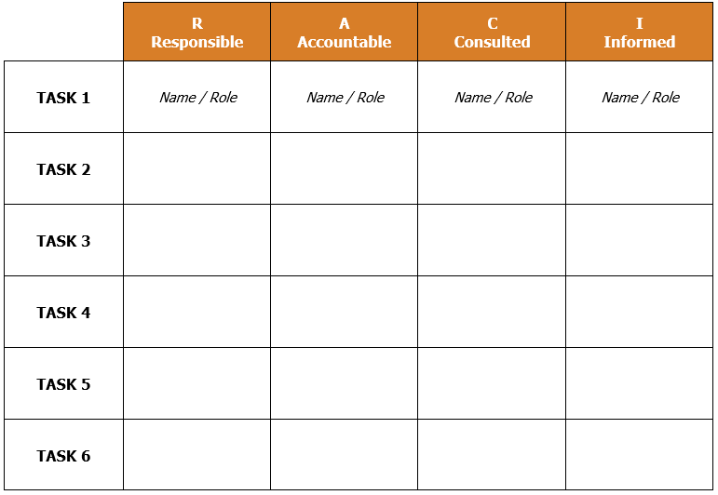
How to Facilitate

1

2

3
It is essential to complete the RACI as a team to validate who should be responsible, accountable, consulted, or informed for each task in the process. Creating a RACI as a team also increases ownership of the success of the process.

Key Components
- Responsible
  - Name the person(s) or role(s) who performs the task

- Accountable
- Name the person or role who authorizes the decisions involved with the task and/or who owns the resources associated with the task. Only one person/role should be accountable for each task.

- Consulted
- Name the person(s) or role(s) who are the subject matter experts for the task, and who provide expertise and insights during the progress of the task.

- Informed
- Name the stakeholder/s to keep informed about the task, but are not needed for their approval, expertise or opinions.

 | R  Responsible | A  Accountable | C  Consulted | I  Informed
TASK 1 | Name / Role | Name / Role | Name / Role | Name / Role
TASK 2
TASK 3
TASK 4
TASK 5
TASK 6

EXAMPLE RACI – Baking a Custom Cake

 | R  Responsible | A  Accountable | C  Consulted | I  Informed
Discuss customer cake order | Baker |  | Customer | Baker’s assistant
Find a recipe | Baker | Baker
Make a list of ingredients | Baker | Baker
Buy ingredients from store | Baker’s assistant | Baker | Grocer
Mix ingredients | Baker’s assistant | Baker | Baker
Bake cake | Baker’s assistant | Baker | Baker
Decorate cake | Baker | Baker | Customer
Deliver cake to customer | Baker’s assistant | Baker |  | Customer

