PRIORITIZATION MATRIX

Purpose
The Prioritization Matrix helps identify the projects, factors, or ideas that should be addressed first in order to maximize improvement and results, while minimizing resources.
How to Facilitate
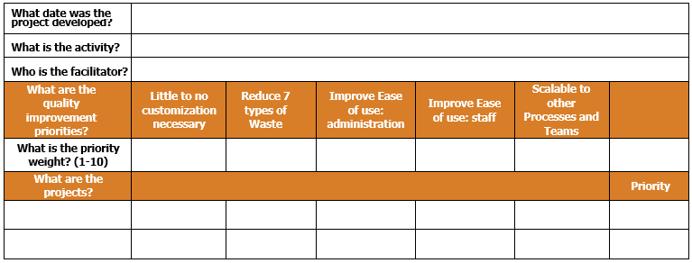
- Identify quality improvement priorities for your team
  - Discuss with your team whether the quality improvement priorities in the template are sufficient (#1 on diagram). If not, remove any you don’t need and brainstorm additional key priorities. Add new priorities to the row.

2

1
  - In the respective cells below, in the row entitled “What is the priority weight?” (#2 on diagram), determine the relative importance of each priority on a scale of 1-10 (1=low priority, 10=high priority).

4

3
- Identify the problems/factors to be addressed

- Guide your team to brainstorm a list of problems/factors that need to be addressed and list these in the column entitled “What are the projects?” (#3 on diagram).
  - In the adjacent columns, determine the importance of each problem/factor with respect to each quality improvement criteria on a scale of 1-10 (1=low importance, 10=high importance).
- Totaling the results
  - This template automatically calculates the final priority score (#4 on diagram) for each problem/factor. This can also be manually calculated by first multiplying the value assigned to each problem/factor by the priority weight given to the quality improvement priority. Sum the products of these two values across the row to calculate the final priority score.
  - Use the final priority score to help prioritize the problems/factors to address.

**Best used as a digital copy so the Priority score will be calculated automatically (double click on the below table). Otherwise, calculate the scores manually following directions listed above.

EXAMPLE PRIORITIZATION MATRIX – Baking a Custom Cake
What date was the project developed? | January 1, 2020
What is the activity? | Baking a Custom Cake
Who is the facilitator? | Baker
What are the quality improvement priorities? | Little to no customization necessary | Reduce 7 types of Waste | Improve Ease of use: administration | Improve Ease of use: staff | Scalable to other Processes and Teams
What is the priority weight? (1-10) | 5 | 10 | 9 | 10 | 8
What are the projects? |  |  |  |  |  | Priority
Discuss customer cake order | 9 | 8 | 10 | 10 | 10 | 395
Find a recipe | 8 | 10 | 9 | 9 | 9 | 383
Make a list of ingredients | 7 | 7 | 8 | 8 | 8 | 321
Get ingredients from grocery store | 6 | 6 | 7 | 7 | 7 | 279
Turn on music | 1 | 1 | 1 | 1 | 1 | 42
Mix ingredients | 5 | 5 | 5 | 5 | 5 | 210
Bake the cake | 4 | 4 | 4 | 4 | 4 | 168
Decorate the cake | 8 | 3 | 1 | 1 | 1 | 97
Deliver cake to customer | 5 | 2 | 5 | 5 | 5 | 180

