**FISHBONE DIAGRAM**

**Purpose**

The Fishbone Diagram is used to identify all the factors potentially contributing to an identified problem. This tool also is a visual representation of all the factors grouped together by theme.

**Related Tools**

If the problem is related to a failed process, a Fishbone Diagram can be completed using factors identified in a Failure Modes Effects Analysis (FMEA). The Fishbone Diagram often leads to a Root Cause Analysis.

**How to Facilitate**

It is essential to complete the Fishbone Diagram as a team that includes subject matter experts (SMEs). Draw the Fishbone Diagram on a whiteboard or chart paper. Fill in the rest of the diagram using sticky notes, with one factor per sticky note, so factors can be easily moved around. Guide your team through a Fishbone Diagram in the following order:

1. 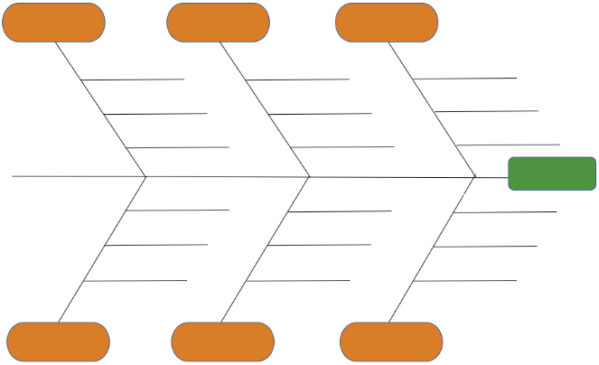Define the problem you are trying to solve as a team. Write this at the head of the fish (blue rectangle; #1 on the diagram).

**2**

**3**

1. Ask your team to brainstorm all the factors that potentially contribute to the problem and write down one factor per sticky note. Stress that there are no wrong answers and that factors can positively or negatively contribute to the problem.

**1**

1. Collect all the factors from the team and read the first factor verbatim. Place it on one of the horizontal lines coming out from one of the “ribs” (#2 on the diagram).
2. With each additional factor, facilitate a group conversation about whether the factor is the same, similar, or different to a factor already placed on the diagram. “Same” factors should be placed on top of the factor to which it is the same, “similar” factors should be placed on an additional horizontal line of a “rib”, while “different” factors should be placed on a different rib.
3. Once all factors have been placed on the Fishbone Diagram, ask your team to consider the factors on each “rib” and provide a name that summarizes the factors on that “rib”. Write the name in the orange bubble (#3 on the diagram).
4. Ask your team to then vote on the factor they want to focus on to address the problem you are trying to solve, considering particular parameters (e.g. within sphere of control, most actionable within a timeframe, most likely to result in a change of output/outcome). Voting, for example, can be done by providing each person two votes, and asking everyone to place a check mark next to the two factors on which they want the team to focus.
5. You can follow this up by then conducting a Root Cause Analysis (5Whys) using the factor with the highest number of votes.

C

What problems prevent the success of your project?





















**KEY:**



What factors cause the process variable to become a problem?

What process/variables contribute to the problem?

Kitchen tools

Stores

Delivery to Customer

Not double checking the variables which contribute to the problem

What process/variables contribute to the problem?

What problems prevent the success of your project?

What factors cause the process variable to become a problem?

**EXAMPLE FISHBONE DIAGRAM – Baking a Custom Cake**



**Recipe**

**Ingredients**

**Oven**

Need to wait for eggs to get to room temperature

Hard to understand

Not working



Takes a long time to find a suitable recipe on the internet

Don’t have the right amount of ingredients and have to go to store

Takes a long time to reach temperature required



Oven timer hard to hear so cake is overdone & have to re-bake

Specialty ingredients have to be sourced online



**Cake is not delivered to customer on time**

Closed & have to go back the next day

Tools are dirty & need to be washed



Wrong address



Discover that the ingredients are too expensive at the store

All the mixing bowls are in use & have to wait

Traffic





Have to stop at many red lights on route

Have to go to multiple stores to find necessary ingredients

Cannot find appropriate tool



**Kitchen tools**

**Delivery to Customer**

**Stores**





What factors cause the process variable to become a problem?

What problems prevent the success of your project?

What process/variables contribute to the problem?

**KEY:**

Kitchen tools

Stores

Delivery to Customer

Not double checking the variables which contribute to the problem

What process/variables contribute to the problem?

What problems prevent the success of your project?

What factors cause the process variable to become a problem?