DATA COLLECTION PLAN
Purpose
The data collection plan describes the types of data that need to be collected as well as the method, source, frequency and who is responsible for collecting the data. This document ensures that all relevant staff are clear on data collection expectations.
Key Components
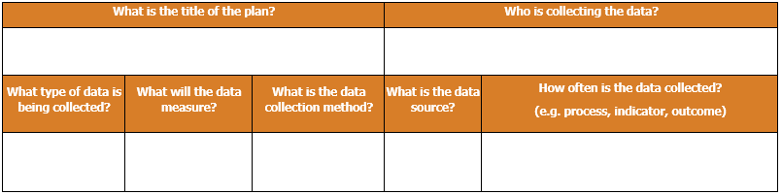

1

2

3

4

5

6

7

- What is the title of the plan?
- This title should be concise, including keywords indicating the name of the project and/or the goal of the project, as well as the date when the plan is finalized (if necessary).
- Who is collecting the data?
- Include the name and position of the person who is collecting the data.
- What type of data is being collected?
- Include the type and name of the data or metrics.
- What will the data measure?
- Include the specific description, the operational definition, or the way the metrics are built.

- What is the data collection method?
- Include the way the metrics will be gathered as detailed as possible.

- What is the data source?
- Brief data sources (i.e. websites, systems, paper surveys).
- How often is the data collected?
- Include a specific date/time when the first round of collection happens. If there is more than one round of data collection, include the frequency/date/time of the subsequent rounds.

What is the title of the plan? |  |  | Who is collecting the data?
What type of data is being collected? | What will the data measure? | What is the data collection method? | What is the data source? | How often is the data collected?  (e.g. process, indicator, outcome)

EXAMPLE DATA COLLECTION PLAN – Baking a Custom Cake

What is the title of the plan? |  |  | Who is collecting the data?
Fulfilling a custom cake order |  |  | Baker
What type of data is being collected? | What will the data measure? | What is the data collection method? | What is the data source? | How often is the data collected?  (e.g. process, indicator, outcome)
Customer Cake Order | Customer Order:  - Type of cake  - Size  - Any special requirements for ingredients and decoration | Read the hand-written notes from the customer order book | Customer | Every cake order, starting May 11
Cake recipe | Each recipe will include methods and ingredients required for the cake that fits into customer order’s requirements | Research recipes and enter chosen recipe and source information into an Excel spreadsheet | Cookbooks and the internet | Every recipe used for a cake order, starting May 11
Time | Customer wait time from order placed to receiving the cake | Two times will be recorded in the customer order book: time when order was taken and time when order was delivered | Clock | Every cake order, starting May 11

